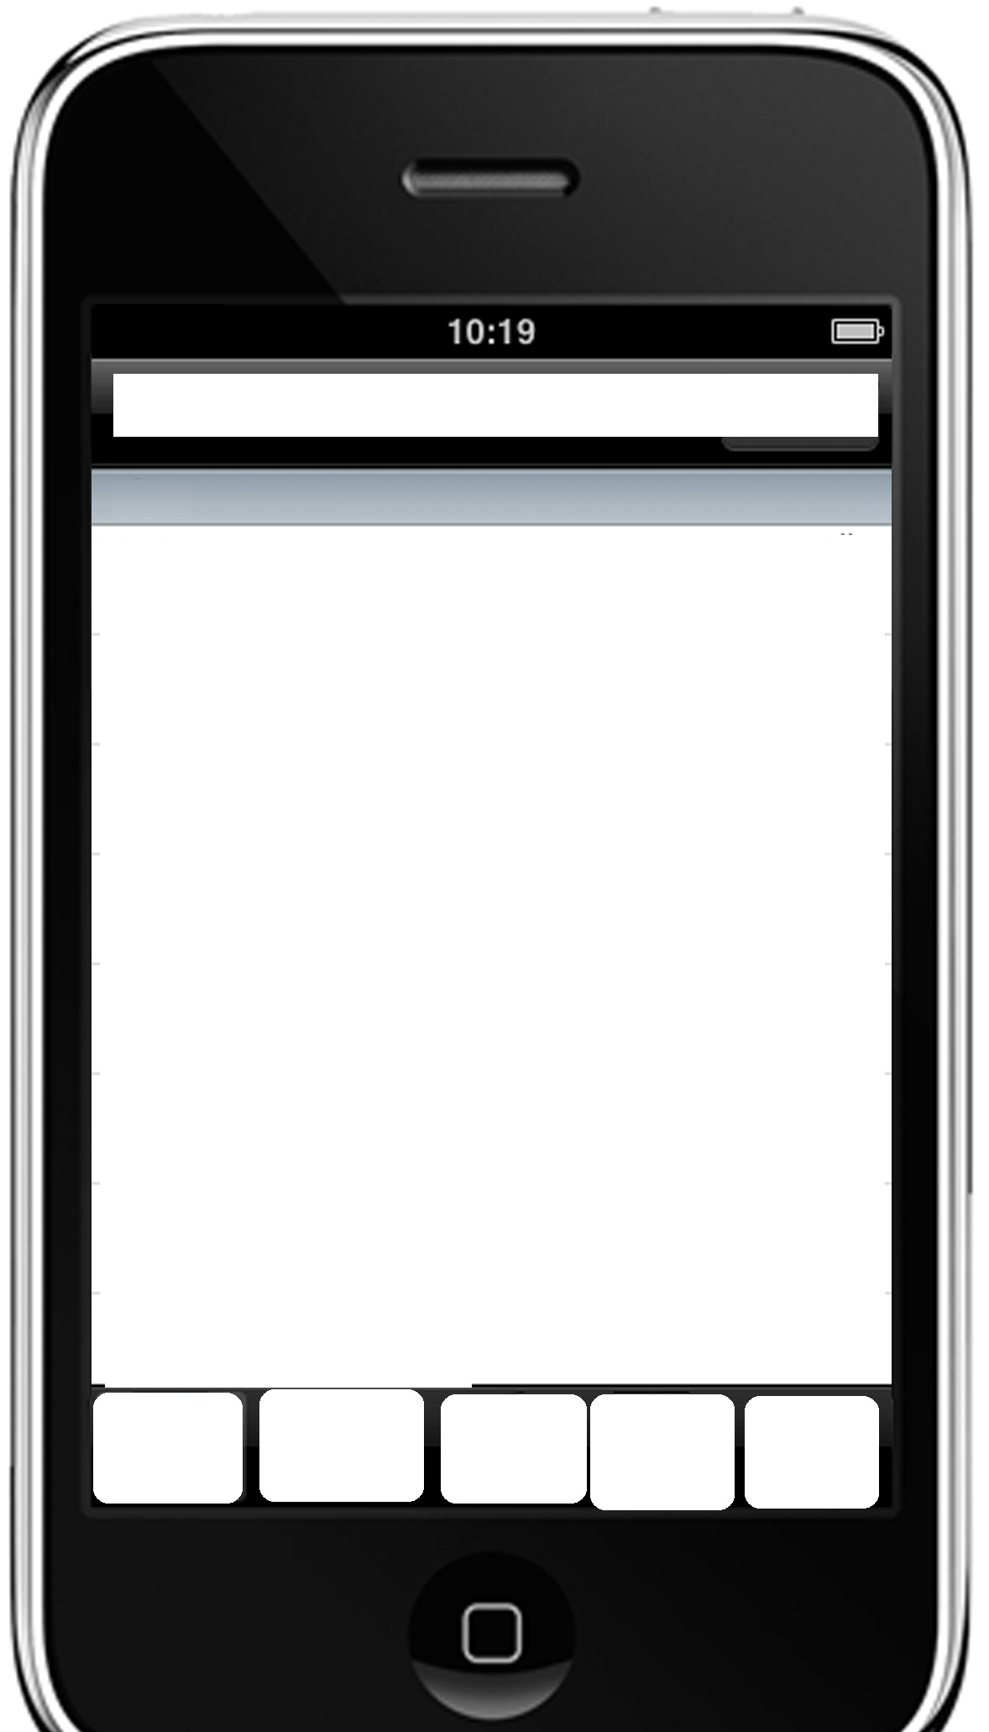

Keep in touch

*Recommend to a friend

**Rate US on App Store
Write a review

Email Support Center
If you can't find a solution to your problems in our Setup section, you can submit a ticket by selecting the appropriate department

Contact US

*should open multi choice box for SMS, email

For SMS:
Content:
Try this great iPhone app: Secure-VPN. It saves $$$ on your data plan and secures your apps & browsing on Wi-Fi and 3G: http://ios.scure-vpn.com.com/sms

For Mail:
Subject:
Be secure and save money with Secure-VPN

Hi,
I found this app that lets you protect your privacy whilst browsing the internet and using various applications and software on either your computer or mobile. Install Secure-VPN on your mobile now and we can both unlimited free Non-Expiry App data.
Download from the AppStore now!

** app store link

*Be Secure, Be Safe and Be Invisible!
Register a New Account **
Get a FREE trial now!
Select a VPN Plan
Unlimited usage multi servers!
List of Protocols
PPTP-SSTP-L2TP-HTTPS-Socks
Setup VPN on iPhone
Automatic installation
My Invoices
View your invoices
My Details
Change your account details

MAIN*

* top and back ground logo: shield-security-icon-psd.psd

(Register a New Account/Check my account status): psd-silver-padlock-security-icon.psd
Select a VPN Plan: psd-guarantee-seal.psd
List of Protocols: checklist-icon-psd.psd
Setup VPN on iPhone: psd-gears-icons.psd (black one)
My Invoices: blank-black-tag.psd
My Details: psd-web-user-icons.psd

** Please refer to our conversations to change the title to:

If http://billing.secure-vpn.com/check.php says whmcs user not yet login then Login or Register a New Account

Else if whmcs user logged in title shows “Check my account status” then Shows My Invoices, Status,My Details

I can change the check.php message depends on your request

*One account for all of your devices!
Auto Setup VPN
One-Click Setup
Manual Setup Guide
Android-Mac-Win-Linux-iOS
List of VPN Errors
PPTP-SSTP-L2TP-HTTPS-Socks
Server Locations
List of available servers

Setup*

Auto Setup VPN
web-buttons-delete-accept-add-exclude.psd (+Sign)

Manual Setup Guide
arrows-stickers-set-psd.psd (refresh icon)

List of VPN Errors
web-buttons-delete-accept-add-exclude.psd (X Sign)

Server Locations
global-social-network-icon-psd.psd

*Back Ground and top logo:
psd-hammer-wrench-icon.psd

PSD icon ( 1month.psd)
PPTP / L2TP / SSTP
24 protocols
Unlimited Bandwidth
128-256 bit Encryption
Instant Activation
Save 0%
PSD icon( 3month.psd)
PPTP / L2TP / SSTP / Squid / Socks
35 protocols
Unlimited Bandwidth
128-256 bit Encryption
Instant Activation
Save 37%
PSD icon( 6month.psd)
PPTP / L2TP / SSTP / Squid / Socks / HTTPS Proxy
42 protocols
Unlimited Bandwidth
128-256 bit Encryption
Instant Activation
Save 42%
HYPERLINK "billing.secure-vpn.com/cart.php?a=add&pid=5" PSD icon( 12month.psd)
PPTP / L2TP / SSTP / Squid / Socks / HTTPS Proxy
42 protocols
Unlimited Bandwidth
128-256 bit Encryption
Instant Activation
Save 57%
PSD icon( 36month.psd)
PPTP / L2TP / SSTP / Squid / Socks Proxy / HTTPS Proxy
42 protocols
Unlimited Bandwidth
128-256 bit Encryption
Instant Activation
Save 73%
*
Please select a VPN plan…

Purchase*

*Back Ground and top logo: psd-red-shopping-basket-icon

